BG
Elevate Retail Operations with DeutSolutions Electronic Shelf Labels
Stop wasting time and money on paper tags. Start achieving perfect pricing, dynamic promotions, and streamlined operations today.

The Future of Retail Pricing is Digital
In the rapidly evolving retail landscape, maintaining pricing accuracy, executing timely promotions, and optimizing labor costs are critical. DeutSolutions Smart Labels replace static paper labels with intelligent, centrally controlled digital displays, transforming how you manage your store shelves.

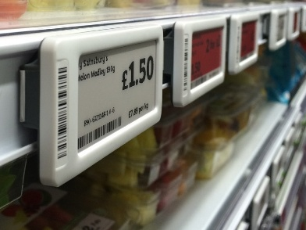

Watch the Future of Retail Pricing in Action
You've read about the power and potential of Smart Labels, now it's time to see how this transformative technology works in the real world.
This short video, featuring a demonstration in a live retail environment, will bring the concepts of dynamic pricing, perfect accuracy, and operational efficiency to life.



Discuss with us your requirements

Key Benefits at a Glance
Feature | Old Paper Tags | DeutSolutions Smart Labels | The Retail Impact
Pricing Accuracy | Manual entry, high error rate | 100% synchronized with POS | Eliminates shrink & customer disputes.
Price Updates | Hours of manual labor | Instant, store-wide updates | Enables dynamic pricing and flash sales.
Labor Cost | High, recurring expense | Near-zero for pricing changes | Reallocates staff to customer service.
Data Display | Limited to basic price/name | Unlimited text, images, QR codes | Provides rich product info and loyalty integration.
Shelf Life | Single-use, high waste | Multi-year operational life | Sustainable and reduces paper consumption.

Our Complete Solution
We don't just sell labels; we deliver a managed system.
- Consultation & Planning: Our experts assess your store layout and recommend the optimal network structure and label sizes.
- Hardware & Installation: We provide state-of-the-art ESL tags, access points, and professional installation services to get you up and running quickly.
- Software & Integration: Our intuitive DeutSolutions CMS allows easy control over pricing rules and promotions, seamlessly integrating with your current retail tools.
- Ongoing Support: 24/7 technical support and maintenance to ensure uninterrupted performance.
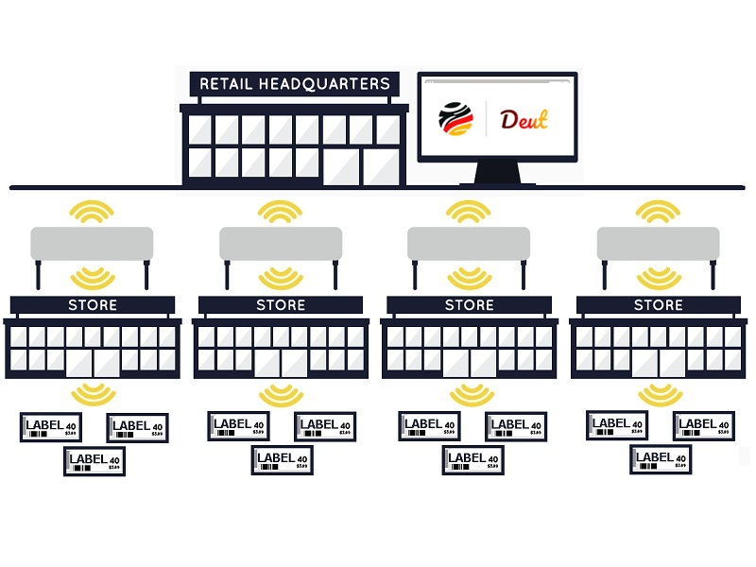

Discuss with us your requirements

Why Choose DeutSolutions Smart Labels?
We provide a complete, end-to-end digital labeling solution designed for rapid deployment and maximum reliability.
1. Instantaneous Dynamic Pricing
Our system allows you to change prices in seconds, not hours.
- Execute time-of-day pricing (e.g., happy hour deals).
- Automatically drop prices on perishable goods nearing expiration.
- React instantly to competitor price changes without lifting a finger.
2. Unmatched Reliability and Display Quality
Utilizing the latest E-Ink/E-Paper technology, our labels are:
- Ultra Low-Power: Batteries last up to 5-7 years, minimizing maintenance.
- Crystal Clear: High contrast, 180-degree viewing angle, and available in multiple colors (Black, White, Red/Yellow).
- Secure Communication: Our dedicated [RF/BLE] network ensures reliable, fast, and encrypted updates across your entire store footprint.
3. Seamless Integration
Our robust API and dedicated integration team ensure the ESL system plugs directly into your existing infrastructure:
- POS System (Point of Sale)
- Inventory/ERP System
- E-commerce Platform (for price parity)

Know more about our solution
You've explored how DeutSolutions Smart Labels deliver pricing accuracy, enable dynamic promotions, and slash operational costs. Now, take the next step to fully understand the impact our solution can have on your business.
Our comprehensive documents and guides provide all the necessary details to move from inquiry to implementation.
- Download Flyer
- Download Overview Presentation
- Download Technical Specifications

Ready to Digitize Your Shelves?
Take the first step toward flawless pricing and maximized efficiency, See the system in action and calculate your potential ROI.

Discuss with us your requirements

